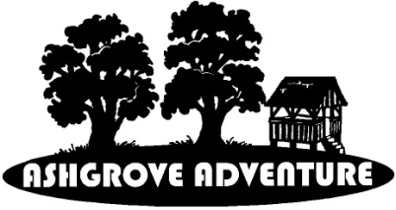 **Ashgrove Adventure Design Contest 2025**

Attention Girl Scouts! You are invited to enter the **Ashgrove Adventure Day Camp Design Contest** to help design our camp t-shirt, camper patch, and staff patch. Winners are guaranteed a spot in Ashgrove but still need to SIGN-UP through Open Registration with GSCNC.

**Folklore & Fairy Tales**

Guidelines:

* Keep the design in the circle *or* flip this page over to do an arch or rectangle  shaped design
* Design must include the words “**Ashgrove Adventure**” and depict the theme **Folklore & Fairy Tales**
* There is no limit on the number of entries per person – send as many as you have ideas!
* Digital entries must be scanned or designed at a minimum resolution of 300 dots or pixels per inch

Mail completed entries no later than **March 6, 2025** to:

Ashgrove Adventure Design Contest, 2427 Freetown Dr. Reston, VA 20191-2511, or

ashgrove.design.competition@gmail.com

We can’t wait to see all the wonderful, creative entries!